Занятие 5: « Внутренние органы человека», «Системы органов»

1.Сделайте конспект по теме «Внутренние органы»
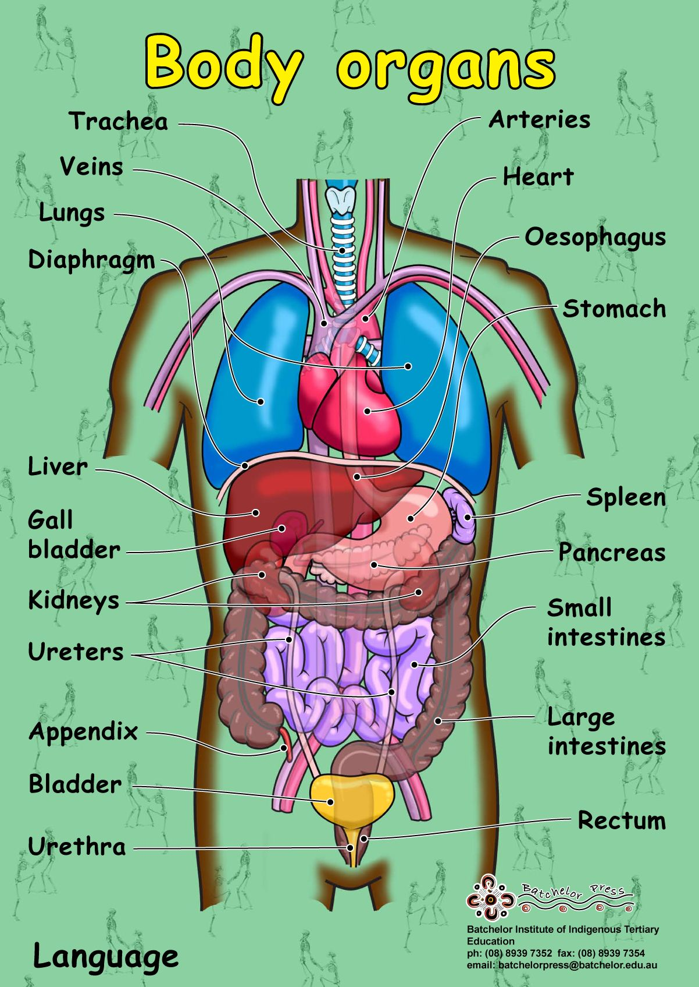

2. Послушайте песню:
https://www.songsforteaching.com/intellitunes/mybody.htm
и напишите, какую функцию выполняют разные органы.

My Body
All my organs …. .
My brain ….,
My lungs are … Putting ….
My heart is ….
My stomach…
My two intestines …
One is … and one is ….
My liver …..
Two kidneys ….

3. Прочтите текст “Systems of the Body” заполните таблицу:

Systems | Organs | Functions
1.
2.
3.
4.
5.
6.
7.
8.

Systems of the Body
There are several main systems of the body: the skeletal, the muscular, the nervous, the digestive, the respiratory, the urinary, the endocrine and the reproductive systems.
The skeletal system consists of the bones of the body and ligaments and cartilages, which join them. The chief function of the skeletal system is structural.
The muscular system consists of the skeletal muscles and their associated structures. The main function of this system is to move us about.
The nervous system consists of the brain and spinal cord, nerves, ganglia and receptors. It is a complex information system with all the necessary means for receiving, processing and communicating information.
The circulatory system consists of the heart and blood vessels and the blood, which is pumped through the blood vessels by the heart. Its function is mainly that of transportation system: the nutrients, oxygen, special substances which are required by cells are carried by the blood stream; and the cellular wastes and sometimes other materials produced by the cells are carried away by the blood stream.
The digestive system consists of the alimentary canal and a number of associated glands.
The respiratory system consists of the lungs, the air passages leading to them and associated structures. Its main function is to convey oxygen to the lungs, where it can enter the blood stream and to remove carbon dioxide, which escapes from the blood into the lung spaces.
The urinary system consists of the kidneys which produce urine by removing nitrogenous and other wastes from the blood: the two ureters, which convey the urine away from the kidneys; the urinary bladder, where the urine is stored until it is discharged; and the urethra through which the urine is discharged.
The endocrine system consists of a number of glands throughout the body, which produce regulatory substances called hormones. The endocrine system serves to regulate a large number of activities.
Notes:
1. to move us about – осуществлять наше движение
2. for receiving, processing and communicating information – для
получения обработки и передачи информации
3. Which are required by cells – которые необходимы клеткам
4. by removing nitrogenous and other wastes – путем выведения
азотосодержащих и других продуктов отхода
5. where urine is stored – где накапливается моча

5. Answer the questions:
1. What are the main systems of the body?
2. What are the functions of the skeletal and muscular system?
3. What does the nervous system consist of?
4. What does the circulatory system include?
5. What does the digestive system consist of?
6. What does the respiratory system include?
7. What does the urinary system consist of?
8. What does the endocrine system include?
9. What is the most important body system? Why do you think so?

6. Выучите названия внутренних органов и названия всех систем тела человекак к следующиему занятию !

